Usecase model – Subscription Management Module

1. **Actors**

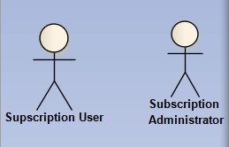

* 1. **Subscription Users:**

A person who registers for our service and pay for it at a fixed interval, daily, weekly or monthly for example.

* 1. **Subscription Administrator:**

A kind of application administrator who responsible for managing subscription user payment.

1. **Primary Use Cases**

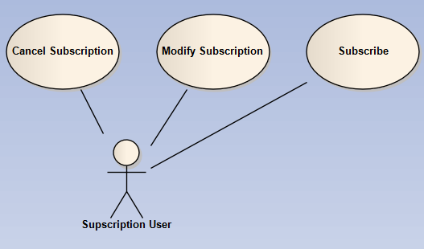

* 1. **Subscribe**

When a user want to use our service, he subscribe for the service.

User choose a service plan

Application displays pricing and service term

User agree to the term

Application display payment options: Via user PayPal account or type credit card directly

User review his order

User submits his subscription. A user subscription profile gets created.

* 1. **Modify Subscription**

User choose another service plan

Application displays pricing and service term

User agree to the term

Application display payment options: Via user PayPal account or type credit card directly

User review his order

User submits his subscription. His new payment amount will be applied at next bill interval

* 1. **Cancel Subscription**

User cancels his subscription.

Subscription cancelled and application does not charge him any more.

* 1. **Manage Subscription**

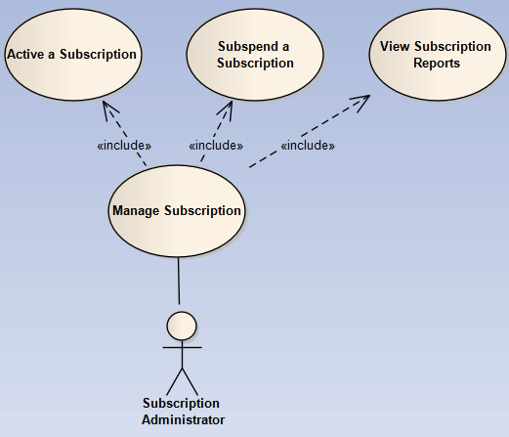

Administrator can manage subscriptions via PayPal tools.